Plano ISD Secondary Mathematics Adopted Curriculum Resources

Subject | Adopted Resource & Publisher | Format | Student Webdesk App | Textbook Image
Middle School Math | Carnegie Learning | Students are provided a consumable textbook and online access to their digital book through PISD Webdesk. | 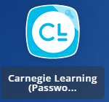 | 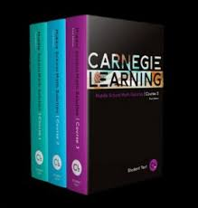
Algebra 1 /  Honors Algebra 1 | Houghton Mifflin Harcourt Algebra 1 | Students are provided a consumable textbook and online access to their digital book through PISD Webdesk. |  | 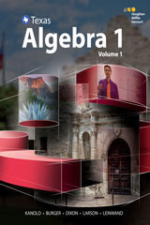
Geometry /  Honors Geometry | SpringBoard Geometry | Students are provided a consumable textbook and online access to their digital book through PISD Webdesk. | 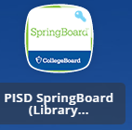 | 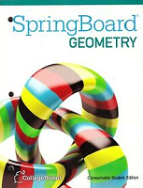
Mathematical Models with Applications  (Math Models) | Modeling with Mathematics: A Bridge to Algebra II (Bedford, Freeman, Worth national edition) | Students are provided a hardbound textbook for checkout and online access to their digital e-book. | 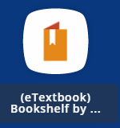 | 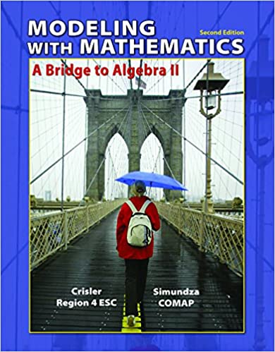
Algebra 2 /  Honors Algebra 2 | Houghton Mifflin Harcourt Algebra 2 | Students are provided a consumable textbook and online access to their digital book through PISD Webdesk. |  | 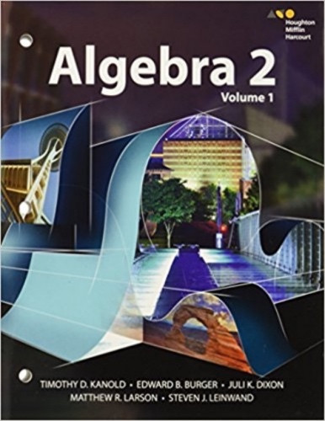
Advanced Quantitative Reasoning (AQR) | Advanced Quantitative Reasoning: Mathematics for the World Around Us (AQR Press  Texas Edition) | Students are provided a hardbound textbook. | N/A | 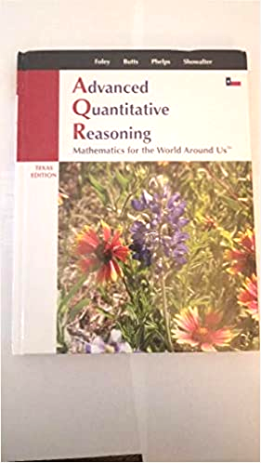
Precalculus / Honors Precalculus | McGraw-Hill Texas Precalculus | Students are provided a hardbound textbook for checkout and online access to their digital book through PISD Webdesk. | 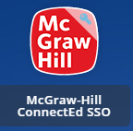 | 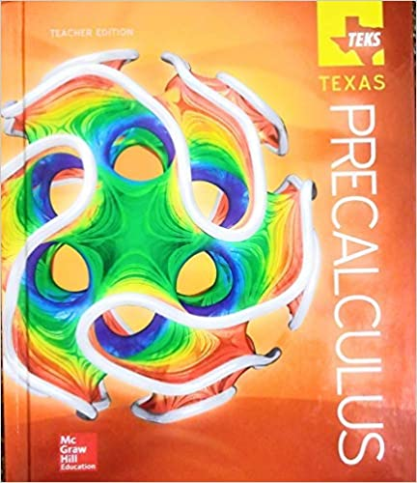
Statistics | Stats in Your World (Pearson/Savvas) | Students are provided a hardbound textbook for checkout and online access to their digital book through PISD Webdesk. Students also have access to the online tool MyMathLab for digital assignments. | 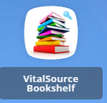 | 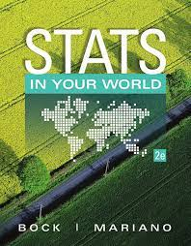
AP Statistics* | The Practice of Statistics (Bedford, Freeman, Worth) | Students are provided a hardbound textbook for checkout and online access to their digital book through PISD Webdesk. Students also have access to the online tool MyMathLab for digital assignments. |  | 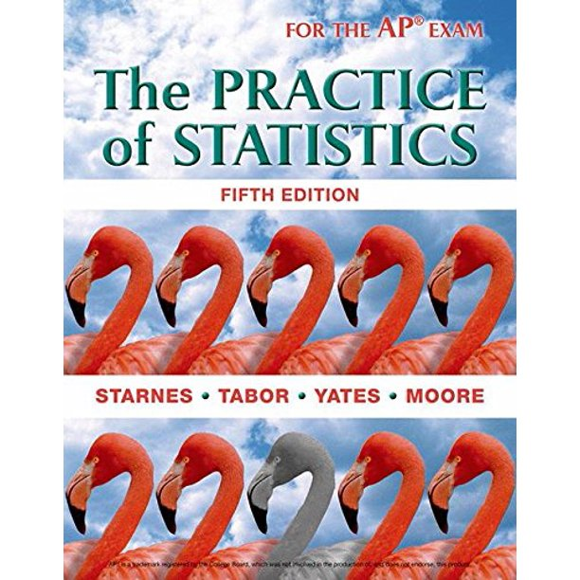
AP Calculus* | Cengage  AP Larson 10th Edition | Students are provided a hardbound textbook for checkout and online access to their digital e-book. |  | 

*Resources for AP, IB, and Dual Credit courses may vary by instructor and by year, to align with governing organizations.

